Peace River Pride Vendor Application
In order to process this application, the agreement must be signed, dated, and returned with payment and this form

Event Information: Saturday, January 18, 2020 - Noon-6 p.m. –
Laishley Park, 95 Nesbit, Punta Gorda, FL

Business/Organization Name:

_______________________________________________________________________________________

Primary Contact Name, Title, and Pronouns (see attached info sheet for pronoun explanation):
_______________________________________________________________________________________

Mailing Address: ________________________________________________________________________

Phone Number(s): _______________________________________________________________________

Email: _________________________________________________________________________________

Please describe your business/organization:

_______________________________________________________________________________________

_______________________________________________________________________________________

What type of goods/services/info will you be offering for purchase or giving away?

_______________________________________________________________________________________

_______________________________________________________________________________________

Vendors’ websites may be linked from the All Rainbow and Allied Youth webpage. Please specify the exact web address for your link:

____________________________________________________________________________________
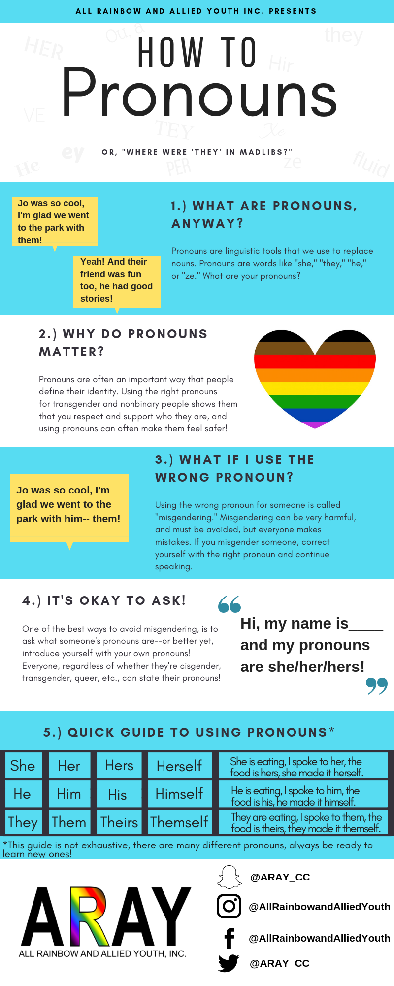

Attention: To be accepted as a Vendor at the 2020 Peace River Pride it is required that All Rainbow and Allied Youth Inc. is named as an additional insured through the Vendor’s insurance policy for the weekend of Peace River Pride. Proof of this must be attached to this application for this application to be processed. Vendors that cannot present proof of insurance will not be accepted.

Electric hook-ups may be provided by request--this may incur an additional fee, contact Pride@AllRainbowandAlliedYouth.org for inquiries prior to application submission.

$100.00 Vendor Fee

Pay by Credit Card: Email Pride@AllRainbowandAlliedYouth.org to set up secure transaction processing.
Enclose Check payable to: ALL RAINBOW AND ALLIED YOUTH, INC*
*Memo Line: Food Truck Feastival Vendor Application

Mail payment and completed agreement to: All Rainbow and Allied Youth Inc.
P.O. Box 494086, Port Charlotte, FL 33949

Pride Vendor agreement for the 2020 Peace River Pride (hereafter, “Pride” or “the Pride”). Vendors with booth space at Pride, agree to each and all clauses set forth in this agreement and identified in the Pride Vendor Request herein incorporated by reference. Failure by the Vendor to abide by any clauses set forth in this agreement gives All Rainbow and Allied Youth Inc. (hereafter known as ARAY) and/or the authorized agent(s) of ARAY the right to (1) immediately terminate this agreement, and (2) require Vendor, immediately upon notice of violation of this agreement, to cease operations and vacate the premises, and (3) forfeit any and all fees paid to ARAY for the right and privilege of participating as a Vendor of Pride. No clauses of this agreement may be changed in any way or altered without the written, signed permission of ARAY.
- FORFEITURE AGREEMENT: Vendor agrees to obey all rules and instructions as directed by ARAY and/or the authorized agent(s) of ARAY during Pride; any failure to strictly adhere to such instructions may result in the immediate termination of this agreement and immediate forfeitures of any and all fees paid to ARAY. Further, Vendor may be subject to fines, civil, and/or criminal liability for violations of law or City of Punta Gorda ordinances.
- SET-UP/TEAR-DOWN: VENDOR MUST BE ON-SITE NO EARLIER THAN 8:00 A.M. and NO LATER THAN 11:00 A.M. AND SET-UP MUST BE COMPLETE NO LATER THAN 11:40 A.M. In the event the Vendor fails to appear at the Festival and claim their reserved market space by 11:00 a.m., Eastern Time Zone, on Saturday, January 18, 2020, ARAY reserves the right to assign, and/or resell, such space to another prospective Vendor without further notice, nor refund, to the undersigned Vendor. If it appears, or it is necessary, for the undersigned Vendor to arrive later than the time noted above, it is the undersigned's responsibility to notify and make arrangements with ARAY. TEAR DOWN: May not begin before 6:00 PM and must be completed by 8 P.M.
- BOOTHS: ARAY agrees to provide each qualifying Vendor of Pride with a 10'x10' space with one 8-foot-long (8') table and two chairs per assigned Vendor space. Vendor is responsible for any equipment necessary for setup (such as dollies, carts, etc). Vendor may provide and is encouraged to provide their own canopy/pop-up tent, no larger than 10’x10’. All Vendors must use weights on each leg of the

canopy/pop-up tent because of possible windy conditions along the harbor. Stakes or inground implements are strongly discouraged. Vendor displays shall be of professional quality. All packaging material and boxes shall be stored out of sight. Electricity is not available at Pride unless specifically requested (an additional charge may be required).
- SUBLETTING PROHIBITED: Vendor shall not sublet to, or otherwise allow use of Vendor’s allotted booth by any other business, organization, or person, with or without cost, without prior written authorization by ARAY.
- PROHIBITIONS: Vendor agrees to and acknowledges that barbeque grills or any open flames are prohibited.
- DAMAGES AGREEMENT: Vendor agrees and acknowledges to abide by all directions from ARAY and the City of Punta Gorda, which seek to protect the environment and infrastructure of City Parks and the safety of Pride patrons, volunteers, and other vendors/sponsors. Vendor hereby acknowledges liability, and agrees to compensate ARAY, for any damage(s) caused by, including but not limited to, its representatives, agents, employees, volunteers, members, vehicles, equipment, materials, objects to the environment and infrastructure of city parks which causes ARAY to pay for the repair, replacement, or other remuneration to the City of Punta Gorda for such damage to the environment or infrastructure of a city park.
- STAY IN ALLOCATED SPACE: Out of fairness and consideration of all Pride participants, Vendor acknowledges and agrees to only utilize such space contained within the confines of the ASSIGNED booth space, and not to extend beyond 5 feet directly in front of its booth, for any sales, distribution, or other solicitation. Vendor acknowledges and agrees that they are strictly prohibited from “canvassing” or otherwise roaming the grounds in any effort to promote its booth's purpose, unless specifically authorized in writing to do so by ARAY at least one week prior to the event.
- NO AMPLIFIED SOUND: As a courtesy to other vendors, sponsors and Pride participants, any amplified sound and loud noise from your booth is prohibited. The only amplified sound allowed at the Pride is by an entertainment provider specifically authorized by ARAY.
- NO ILLEGAL OR OBSCENE MATERIALS: Vendor shall not display, offer for view, or sell any illegal or contraband items. Additionally, Vendor acknowledges and agrees that any material of a nature which may be considered hateful, obscene, or objectionable for view by minors shall not be displayed. ARAY shall have sole and final discretion over what shall constitute obscene or objectionable items not otherwise prohibited by law or ordinance.
- NO COMPETING FOOD/BEVERAGE SALES: ARAY retains the exclusive rights to serve and sell any and all food and beverages at Pride. Out of fairness to specifically authorized Pride “Food Vendors,” serving or selling any beverage or food except by the specifically authorized “Food Vendors” is prohibited. ARAY reserves the right to confiscate for the duration of Pride any food or beverages being served or offered for sale by anyone other than the specifically authorized “Food Vendors.”
- NO COMPETITION WITH ARAY: Vendor shall not display, offer for view, take orders for, sell, or solicit for donation any items that are imprinted, emblazoned, or marked in any manner with “All Rainbow and Allied Youth”, “Peace River Pride Charlotte County”, or the All Rainbow and Allied Youth, Inc. names or logos. Even when printed with other words, Vendor shall not offer phrases, logos or artwork with any variations of these words.
- NO COMPETITION WITH FESTIVAL SPONSORS: ARAY reserves the right to prohibit, within any Pride booth or on the grounds, the display, advertisement, or other promotion of any business, company, or organization which may be in conflict with a current ARAY sponsor. Any questions concerning current ARAY sponsors should be directed to ARAY prior to Pride.
- SALES TAX: Vendor acknowledges and understands that they are responsible for sales and use tax and shall in no way hold ARAY or its representatives responsible for any type of permits other than for Pride itself. Vendor is solely responsible for the acts or omissions, and any and all costs associated therewith, of any and all of its employees and volunteers.
- NO MISREPRESENTATION: No Vendor shall hold itself out as an agent of ARAY.
- CANCELLATIONS / REFUND POLICY: Rain Date is January 19. No refunds are offered.
- POSSESSIONS: All booths and exhibits must be tended at all times. ARAY and the City of Punta Gorda accept no responsibility for items left unattended. Vendor is solely responsible for the security of their property
- ATTENDANCE NOT GUARANTEED: ARAY makes no representation or guarantees towards actual Pride attendance.
- UNCONTROLLABLE EVENTS: Vendor understands that ARAY has no control over attendance, weather, acts of God, acts of terrorism, governmental intervention, or any cause that may prevent, alter, or interrupt Pride; Vendor shall hold ARAY harmless for any losses that could arise as a result. ARAY does not refund booth fees due to weather, acts of God, acts of war or terrorism, or governmental intervention; Pride is a “Rain or Shine” event.
- PLACEMENT: ARAY reserves the right to place Vendor in any booth location at the complete discretion of ARAY, irrespective of the participant's request. ARAY makes no representation, nor does it guarantee any volume of “foot-traffic” of Pride guests in any area of Pride. ARAY cannot speculate, nor control, the popularity of one area of Pride over the other.
- CLEAN UP: Vendor, upon vacating their booth space(s), will ensure that such space shall be free of any and all trash or refuse with such being placed in the appropriate refuse containers. Failure of the Vendor to clean their booth site may result in the future denial of Vendor participation.
- HOLD ARAY HARMLESS: Vendor understands and agrees that Vendor, Vendor’s business, organization, employees, assistants, coworkers, heirs, or assigns, shall hold harmless ARAY, their organizers, agents, directors, volunteers, other Vendors, insurance carriers, and site property owner in the case that Vendor or any person associated with Vendor suffer any damages or loss to goods, wares, or merchandise; or accident, illness, injury, death within the confines and context of Pride. Vendor agrees to not file any claim(s) against ARAY or their organizers, directors, agents, volunteers, other Vendors, insurance carriers, or the City of Punta Gorda. Vendor agrees that Vendor or Vendor’s insurance shall have sole responsibility for any and all costs associated with injury, illness, or loss suffered at or related to the Pride.
- INSURANCE: Vendor certifies that Vendor maintains adequate insurance and has named All Rainbow and Allied Youth Inc. as the additional insured for the days of FTF. Vendor understands that liability insurance may be available for private purchase and if interested in additional information, shall contact Vendor’s preferred insurance agent.
- FINES INCURRED BY VENDOR: Any infraction or damage that results in ARAY being charged a fine by the City of Punta Gorda will be billed directly to the responsible Vendor.
- TERMINATION CLAUSE: Any failure to strictly adhere to any part of this agreement may result in the immediate termination of this agreement and immediate forfeitures of any and all fees paid to ARAY.
- SEVERABILITY CLAUSE: “If any term of this Agreement is to any extent illegal, otherwise invalid, or incapable of being enforced, such term shall be excluded to the extent of such invalidity or unenforceability; all other terms hereof shall remain in full force and effect; and, to the extent permitted and possible, the invalid or unenforceable term shall be deemed replaced by a term that is valid and enforceable and that comes closest to expressing the intention of such invalid or unenforceable term. If application of this Severability provision should materially and adversely affect the economic substance of the transactions contemplated hereby, the Party adversely impacted shall be entitled to compensation for such adverse impact, provided the reason for the invalidity or unenforceability of a term is not due to serious misconduct by the Party seeking such compensation.”

This agreement supersedes all oral or other non-written agreements and understandings. Any modification of this agreement shall be null and void unless said modification is set forth in writing and signed by the same parties (or their representatives) having made this agreement. This agreement has been read, understood and entered into freely, voluntarily and absent of duress by the parties signed below. Vendor agrees to abide by all clauses set forth in this agreement, and upon notice of violation of this agreement to immediately vacate Pride and forfeit any and all fees paid for the privilege of participation in Pride.

I, Authorized Representative (printed name): _________________________________________ agree to honor all items delineated within this agreement.

Signature: ________________________________________________________________

Date: ________________________________

All Rainbow and Allied Youth, Inc reserves the right to deny any applicant for any reason with or without cause.

